**1. What is DevOps? How is it different from Waterfall and Agile methodology?**

**DevOps is a set of practices, tools, and a cultural philosophy that automates and integrates the processes between software development and IT operations teams. Its core tenets are collaboration, streamlined processes, and the use of shared tooling. This contrasts sharply with the Waterfall methodology, which is a linear, sequential approach where each phase must be completed before the next begins. Waterfall's long cycles and infrequent deployments are antithetical to DevOps' emphasis on speed and continuous improvement.**

**Agile methodologies, while iterative and incremental, often fall short of fully realizing the potential of DevOps. While Agile focuses on iterative development and close collaboration between developers and business stakeholders, it often lacks the seamless integration with operations that DevOps provides. In Agile, the handoff between development and operations can still create bottlenecks and delays. DevOps bridges this gap by integrating operations into the development lifecycle from the outset, fostering a shared responsibility for the entire software delivery pipeline. This results in faster deployment cycles, improved quality, and increased efficiency compared to both Waterfall and traditional Agile implementations. The key difference lies in the complete integration of operations into the development process, creating a unified team with shared goals and responsibilities.**

**2. Explain the 3 Axis of DevOps Culture with a neat diagram**

**The three axes of DevOps culture are:**

**\* **Collaboration:** This is the foundational element, emphasizing the breakdown of traditional silos between development (Dev), operations (Ops), and testing teams. Instead of separate teams with distinct objectives, DevOps promotes the formation of multidisciplinary teams. These teams share a common goal: delivering value to the end-user as rapidly and efficiently as possible. This collaborative approach fosters better communication, shared responsibility, and faster problem-solving.**

**\* **Processes:** DevOps relies heavily on agile methodologies and iterative development processes. Continuous Integration (CI) automates the integration of code changes, allowing for frequent testing and early detection of issues. Continuous Delivery (CD) automates the release process, making deployments faster and more reliable. The difference lies in that Continuous Delivery automates the *preparation* for release, while Continuous Deployment automates the *actual* release to production. The DevOps process itself is iterative, typically involving phases like planning, development, testing, and deployment.**

**\* **Tools:** Automation is key to DevOps success. Tools are used to automate various aspects of the software development lifecycle, from code integration and testing to deployment and infrastructure management. Infrastructure as Code (IaC) is a crucial aspect, allowing infrastructure to be managed and provisioned through code, enhancing consistency and repeatability. This automation reduces manual effort, minimizes errors, and accelerates the delivery pipeline.**

**\*\*Diagram:\*\***

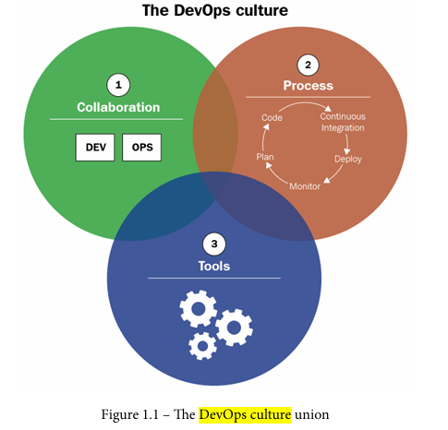

**The overlapping areas represent the synergy between the three axes. Effective DevOps implementation requires a strong interplay between collaboration, well-defined processes, and the right tools. The central overlapping region represents the core of the DevOps culture, where these three elements work together to achieve continuous delivery of value.**

**3. List and explain benefits of establishing a DevOps culture**

**Implementing a DevOps culture yields several significant benefits across various aspects of software development and deployment:**

**\* **Improved Collaboration and Communication:** DevOps fosters a collaborative environment breaking down silos between development (Dev) and operations (Ops) teams. This enhanced communication streamlines workflows and facilitates quicker problem resolution. The human and social impact within the company is also positive, leading to a more unified and efficient workforce.**

**\* **Faster Time to Market:** By embracing agile methodologies and CI/CD pipelines, DevOps significantly reduces lead times for production deployments. This allows organizations to respond more quickly to market demands and deliver value to end-users faster.**

**\* **Higher Quality Deployments:** The integration of automated testing (unit, integration, and potentially BDD/TDD) ensures higher quality software releases. Frequent, smaller deployments minimize the risk associated with large-scale releases, leading to fewer errors and improved stability. The use of feature flags further enhances this by allowing for dynamic feature enabling/disabling without redeployment.**

**\* **Reduced Costs:** DevOps practices, particularly Infrastructure as Code (IaC), lead to reduced infrastructure costs through automation and efficient resource utilization. Automation also reduces manual tasks, freeing up developer time for more valuable activities. The reduction in errors and faster deployments also contribute to cost savings.**

**\* **Increased Customer Satisfaction:** Faster delivery of higher-quality software directly translates to improved end-user satisfaction. The ability to quickly incorporate user feedback through effective feedback mechanisms further enhances this aspect.**

**In essence, DevOps is not just a set of tools or processes; it's a cultural shift that prioritizes collaboration, automation, and continuous improvement, ultimately leading to a more efficient, cost-effective, and customer-centric software delivery process.**

**4. With a neat diagram explain the Continuous Integration (CI) in detail**

**Continuous Integration (CI) is a development practice where developers integrate code into a shared repository frequently, ideally several times a day. Each integration is then verified by an automated build and automated tests. This approach aims to detect integration problems early and minimize the cost of resolving them.**

**\* **Core Components:\*\***

**\* **Version Control System (VCS):** A centralized repository (like Git) is crucial. All developers commit their code changes to this shared repository. The text mentions Git and GitFlow branching strategies as examples of how to manage this process effectively. Using a branch like `develop` allows for integration and testing before merging into the main branch (`master`).**

**\* **Automated Build:** The CI server automatically compiles the code from the repository after each commit. This ensures that the code compiles correctly and identifies compilation errors immediately.**

**\* **Automated Tests:** A suite of automated tests (unit, integration, etc.) is executed after the build. These tests verify the functionality and quality of the code. Early detection of failures prevents bugs from propagating to later stages.**

**\* **CI Server:** A dedicated server (e.g., Jenkins, GitLab CI, CircleCI) is responsible for orchestrating the build and test processes. It monitors the repository for changes, triggers builds, runs tests, and provides feedback to the developers.**

**\* **Feedback Mechanism:** The CI server provides immediate feedback to the developers on the success or failure of the build and tests. This rapid feedback loop is essential for quickly identifying and resolving issues.**

**\* **Diagram (Textual Representation):\*\***

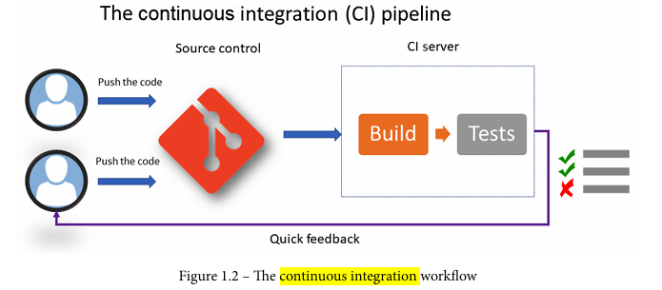

**The diagram shows developers committing code to a shared repository. The CI server automatically detects these changes, builds the code, runs tests, and reports the results back to the developers. This cycle repeats with each code commit, ensuring continuous integration and early detection of problems.**

**The benefits of CI include early detection of integration issues, reduced risk of large-scale integration problems, improved code quality, and faster feedback loops, leading to quicker resolution of bugs and ultimately faster delivery of features. The contrast between this and the described scenario of frequent hotfixes highlights the importance of a well-implemented CI process.**

**5. With a neat diagram explain the Continuous Delivery (CD) in detail**

**Continuous Delivery (CD) is an extension of Continuous Integration (CI), automating the release process to various environments. It takes the artifact built and tested in CI and deploys it to staging and potentially production environments. The key difference between CI and CD lies in the scope: CI focuses on code integration and testing, while CD focuses on automated deployment and release.**

**\*\*Diagram:\*\***

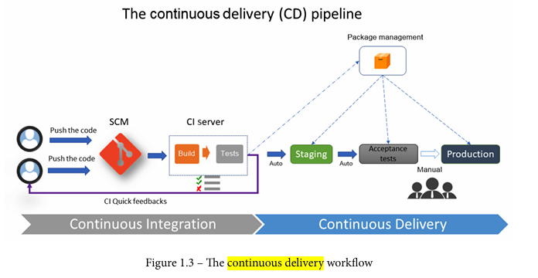

**\*\*Detailed Explanation:\*\***

**1. **CI Artifact:** The process begins with a successfully built and tested application package generated by the CI process. This package is stored in a central repository or package manager (like Artifactory, Nexus, or Azure Artifacts). This ensures version control and easy access for subsequent deployment stages.**

**2. **Automated Deployment to Staging:** CD automatically deploys this package to one or more staging environments. These environments mirror the production environment as closely as possible, allowing for thorough testing in a realistic setting. The deployment process involves a series of automated tasks, such as unzipping files, restarting services, configuring environment variables, and running functional and acceptance tests.**

**3. **Manual Deployment to Production (Often):** While staging deployments are typically automated, production deployments often involve a manual step. This allows for a final review and approval before releasing the application to end-users. This manual gate helps mitigate risks associated with deploying to a live environment. However, a fully automated continuous *deployment* pipeline is also possible, eliminating this manual step.**

**4. **Testing and Feedback:** Throughout the CD process, testing is crucial. Automated tests in staging environments help identify issues before they reach production. Feedback loops are essential to ensure that any problems are addressed promptly.**

**5. **Environment-Specific Configurations:** The same application package is deployed across different environments (development, testing, staging, production). However, environment-specific configurations (database connections, API keys, etc.) are managed separately, often through configuration management tools. This ensures that the application behaves correctly in each environment without modifying the core application package.**

**6. What is Continuous Deployment? How is it different from Continuous Delivery?**

**Continuous Deployment (CD) is an automated process extending Continuous Delivery (CD). It automates the entire CI/CD pipeline, from code commit to production deployment, encompassing all verification steps (unit, functional, integration, performance testing, etc.). Unlike Continuous Delivery, which automates deployment to non-production environments (like staging), Continuous Deployment pushes every successful build directly to production without manual intervention.**

**The key difference lies in the final deployment stage. Continuous Delivery stops short of production deployment; it prepares the application package and verifies it in staging, requiring manual approval before release to production. Continuous Deployment, however, eliminates this manual step, automatically deploying to production upon successful completion of all tests.**

**This automation, while highly desirable for speed and efficiency, presents significant challenges. The extensive testing required to ensure production readiness is a major hurdle. A robust rollback strategy is also crucial to mitigate potential issues arising from automated deployments. Feature toggles can be employed to manage the release of new features, allowing for controlled rollout and quick disabling if problems occur. Because of these complexities, Continuous Deployment is less commonly adopted than Continuous Delivery in enterprise settings.**

**7. With a neat diagram explain the different techniques of implementing Continuous Deployment.**

**Continuous Deployment (CD) automates the release of software from the commit stage to production. Two key techniques facilitate this:**

**\* **Feature Flags (Feature Toggles):** This technique involves encapsulating application functionalities within "features" controlled by flags. These flags can be toggled on or off in production *without* requiring a code redeployment. This allows for releasing new features incrementally, testing them in a live environment with a subset of users, and quickly disabling them if issues arise. A simple diagram would show a codebase with various features, each controlled by a separate flag accessible via a configuration system (e.g., a database, a dedicated feature flag service). The diagram would illustrate how changing the flag state alters the feature's behavior in the live application.**

**\* **Blue-Green Deployments:** This approach utilizes two identical production environments: "blue" (live) and "green" (staging). New code is deployed to the "green" environment. Once testing and validation are complete, traffic is switched from "blue" to "green," making the new version live. If problems occur, traffic can be quickly switched back to "blue." A diagram would show two identical environments, with traffic routing depicted by arrows switching between them. This minimizes downtime and risk.**

**A combined diagram could show the CI/CD pipeline culminating in a deployment decision point. This point would branch into either a feature flag deployment (for incremental releases) or a blue-green deployment (for complete version updates). The diagram would illustrate how both techniques contribute to a smooth and reliable continuous deployment process. The choice between these techniques depends on the application's complexity, risk tolerance, and release strategy. For example, feature flags are ideal for A/B testing and canary releases, while blue-green deployments are better suited for larger, more impactful releases.**

**8. What are laC Practices? List the benefits of laC Practices.**

**IaC (Infrastructure as Code) practices involve managing and provisioning infrastructure through code, rather than manual processes. Key practices include:**

**\* **CI/CD Integration:** IaC code should be integrated into a CI/CD pipeline for automated testing and deployment across various environments. Tools like Terratest facilitate infrastructure code testing. Ideally, the infrastructure CI/CD pipeline is integrated with the application's pipeline.**

**\* **Idempotency:** IaC scripts must be idempotent, meaning they can be run repeatedly without causing unintended changes. The scripts should check the current infrastructure state and only make necessary modifications. This avoids errors from repeated executions.**

**\* **Development Environment:** A dedicated development environment for IaC is crucial. This allows for testing and experimentation without impacting production or integration environments. Tools like Vagrant can simulate local environments for testing.**

**The benefits of adopting IaC are numerous:**

**\* **Standardization:** IaC leads to standardized infrastructure configurations, reducing errors and inconsistencies.**

**\* **Version Control:** Infrastructure code is versioned in a source code manager (like Git), enabling tracking of changes, collaboration, and rollback capabilities.**

**\* **Automated Deployments:** IaC significantly speeds up and improves the efficiency of infrastructure deployments.**

**\* **Improved Management and Cost Reduction:** Better management and control over infrastructure resources lead to reduced costs.**

**\* **DevOps Team Efficiency:** IaC empowers Ops teams to focus on improvements rather than manual configuration, and allows Dev teams to make infrastructure changes independently.**

**\* **Self-Service Environments:** IaC enables the creation of self-service, ephemeral environments, providing developers and testers with greater flexibility for isolated testing.**

**9. Describe different laC Languages used in DevOps. Explain the same with simple code snippet.**

**The provided text describes three main categories of IaC languages: scripting, declarative, and programmatic. Let's examine each with examples:**

**\* **Scripting Languages:** These use scripting languages like Bash, PowerShell, or others in conjunction with cloud provider SDKs (Software Development Kits) to automate infrastructure provisioning. They are imperative, meaning they specify *how* to achieve a desired state.**

**\* **Example (Azure CLI - Bash):** The text provides an example of creating an Azure resource group using the Azure CLI: `az group create --location westeurope --resource-group MyAppResourcegroup` This is a single command, but a more complex script could chain multiple commands to create a complete infrastructure. Note that this is not a complete code snippet in the sense of a function or program, but rather a single command illustrating the concept. A full script would involve more commands and potentially error handling.**

**\* **Declarative Languages:** These languages (like Terraform) define the *desired* state of the infrastructure, and the tool figures out how to achieve it. This is a more abstract approach, focusing on "what" rather than "how." The provided text does not give a code snippet for a declarative language. However, a simple Terraform example (not from the text) would look like this:**

**```terraform**

**resource "azurerm_resource_group" "example" {**

**name = "example-resources"**

**location = "West Europe"**

**}**

**```**

**\* **Programmatic Languages:** These use general-purpose programming languages like TypeScript, Python, Java, or C# with tools like Pulumi or Terraform CDK to define infrastructure as code. They offer the flexibility of a full programming language, allowing for complex logic and reusable components.**

**\* **Example (TypeScript with Terraform CDK - partial, from the text):** The provided text shows a snippet of TypeScript code using the Terraform CDK:**

**```typescript**

**const rg = new ResourceGroup(this, 'cdktf-rg', {**

**name: 'MyAppResourceGroup',**

**location: 'West Europe',**

**});**

**```**

**This is a partial example; a complete program would require more code to set up the project and potentially handle other resources.**

**10.List and explain The laC Topologies.**

**The provided text focuses on the benefits and practices of Infrastructure as Code (IaC) and doesn't describe specific IaC topologies. IaC topology isn't a standard term like network topology. Instead, the architecture and structure of an IaC deployment depend heavily on the specific needs of the organization and the tools used. However, we can discuss common architectural patterns and considerations within an IaC context.**

**\* **Centralized vs. Decentralized:** IaC can be managed centrally, with a single team responsible for all infrastructure code, or decentralized, with different teams managing their own infrastructure. A centralized approach offers better consistency and governance but can become a bottleneck. Decentralization allows for faster iteration but requires careful coordination to avoid conflicts.**

**\* **Mono-repo vs. Multi-repo:** All IaC code can reside in a single repository (mono-repo), or it can be split across multiple repositories (multi-repo). Mono-repos simplify dependency management and promote code reuse but can become unwieldy for large organizations. Multi-repos offer better modularity and scalability but require more careful coordination.**

**\* **State Management:** A crucial aspect of IaC is how the desired state of the infrastructure is defined and managed. Tools like Terraform use a state file to track the current infrastructure configuration. This state file needs to be carefully managed to avoid inconsistencies. Different strategies exist for managing state, including remote state storage and locking mechanisms.**

**\* **Version Control:** Like any code, IaC code should be version-controlled using Git or a similar system. This allows for tracking changes, collaboration, and rollback capabilities. Branching strategies should be carefully considered to manage concurrent changes.**

**\* **Continuous Integration/Continuous Delivery (CI/CD):** IaC should be integrated into a CI/CD pipeline to automate the deployment process. This ensures that changes are tested and deployed consistently and reliably. This often involves automated testing of the IaC code itself, as well as the resulting infrastructure.**

**The text highlights the importance of a development environment for IaC, suggesting tools like Vagrant for local testing. This is a crucial aspect of any IaC topology, regardless of the specific architecture chosen. The principles of software engineering, including testing and version control, are equally applicable to IaC.**

**11.Describe the lac best practices followed in DevOps pipoline.**

**Best practices for Infrastructure as Code (IaC) within a DevOps pipeline encompass both general software development principles and IaC-specific considerations. The core idea is to treat infrastructure code like application code, leveraging version control, automation, and continuous integration/continuous delivery (CI/CD).**

**\* **Software Development Best Practices:** IaC benefits from applying established software engineering principles. This includes using clear and consistent naming conventions (nomenclature), avoiding excessive comments, writing modular code with small, focused functions, and robust error handling. Following the principles outlined in Robert Martin's "Clean Code" is highly recommended.**

**\* **IaC-Specific Best Practices:** Beyond general software development, several IaC-specific practices are crucial:**

**\* **Complete Automation:** All infrastructure provisioning steps must be automated within the code. Manual interventions undermine the benefits of IaC and introduce inconsistencies and errors. This ensures repeatability and reduces human error.**

**\* **Version Control:** Infrastructure code should be stored in a version control system (like Git) enabling tracking of changes, collaboration, and rollback capabilities. This is fundamental for managing infrastructure changes effectively.**

**\* **CI/CD Integration:** IaC code should be integrated into CI/CD pipelines. This allows for automated testing, validation, and deployment of infrastructure changes, ensuring consistency and speed. Tools like Terraform and Ansible can be integrated into Azure DevOps pipelines (as shown in the provided links) to achieve this.**

**\* **Idempotency:** IaC code should be idempotent, meaning it can be run multiple times without causing unintended side effects. This ensures consistency and prevents accidental modifications during repeated deployments.**

**\* **Modular Design:** Break down infrastructure into reusable modules to promote consistency and reduce redundancy. This improves maintainability and allows for easier scaling.**

**\* **Testing:** Implement thorough testing strategies, including unit tests, integration tests, and potentially even end-to-end tests, to validate the infrastructure code before deployment.**

**\* **Security:** Security should be a primary concern. This includes secure storage of credentials, using least privilege principles, and implementing security scanning tools within the CI/CD pipeline.**